Вибір професії.

*05.04.22 9А Хоменко А.Ю.*

*Хід уроку.*

1. *Writing. (Уявіть собі, що ви вже працюєте. Дайте відповіді на питання письмово).*
2. *Do you work on the earth or under the earth?*
3. *Do you work with many people?*
4. *Do you often travel in your job?*
5. *Do people need higher education to have your job?*
6. *Reading and translating. ( Шановні діти, прочитайте текст і перекладіть усно.)*

Every day many people work for us. Let us call them our helpers. How do they help us? A farmer helps us to have good things to eat. He grows all kinds of grain am vegetables for us. A baker makes bread for us. A postman brings us letters, newspapers and magazines. A barber cuts our hair, he shaves grown-up men. A shoemaker mends shoes for us. A dressmaker makes our clothes. A driver drives car, buses and trolley-buses. An engine driver drives a train for us. A miner digs coal for us. A fitter fits up new machines. A turner turns new metal parts. A joiner makes furniture. A builder builds houses for us. A fireman comes when somebody's house is on fire and puts out the fire. He carries grown-ups and children out of the houses and saves their lives. A doctor cures us. He comes when we are ill and gives us medicine. A teacher teaches us many interesting things.

1. *Writing. (Сьогодні ти вже частіше замислюєшься про те, ким ти хочеш бути. Яка професія тобі більше подобається? Подумай і склади декілька речень).*

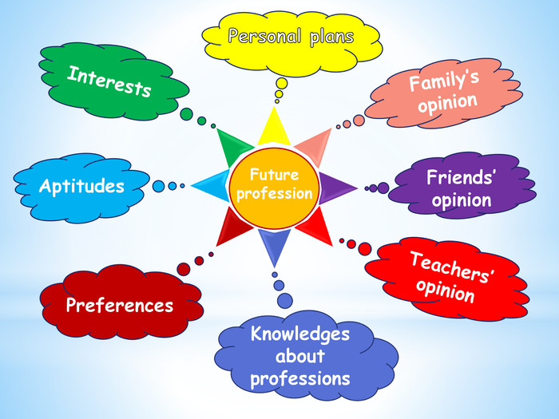

**Home work**: Шановні діти, ми продовжуємо тему «Професії».

- Опрацюйте конспект уроку.

- Напишіть вашу думку стосовно вибору професії.

- Прочитайте і перекладіть текст.